NEW ENGLAND INSTITUTE OF TECHNOLOGY

Information Technology Department

Quest #4

Design Patterns (GDS 393)
Due: Week #4



Jesse Golembiesky

Developer

8/8/2017

Date

George Saban

Instructor
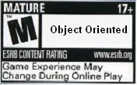



Requirements:

Hand In Instructions
- Make a copy of this entire document and add your work into it.
- Copy your source code (if available) and paste it in the “Code Development” section below.
- Make screen shots (if available) of all your screens and paste it in the “Production Deployment” section below.
- Submit this completed document with your solution and screen shots pasted. Hardcopy submission is preferred, or you may email it to me.
- Submit the electronic zip version of your program on the same electronic media.
- [You can earn a maximum of 30 points for this lab. Refer to the syllabus for late point deductions.]

Problem Statement

Create your own problem that can be elegantly solved using the Singleton Pattern. In other words, come up with a problem that is solvable using the Singleton Pattern.
- In 200 words or more, write the detailed description of the problem.
- And then solve the problem by applying the Singleton Pattern. Implement your solution using the Java language.

Alternatively, you may solve the problem shown below.

Good old Johnny Codefingers just graduated from NEIT and got a job at Rockstar New England as a game programmer. Johnny’s first project is a dungeon crawler game where players take down giant monsters. During the first sprint he has to test a boss fight. He has to create a boss class implementing the Singleton method, to ensure players are always attacking the same boss. The player class must be able to have many instances because it is a multiplayer game For this dungeon we will hard code three Player objects. The player objects must have a function called attack() that will allow the player to reduce the boss’s health. The method accepts the boss object as a parameter and returns the boss health as an int. The attack method does damage equal to the value of their attackPower variable. The players will have different attack powers set through the setAttackPower() method, and will be able to return their values through the getAttackPower() method. The boss will have 100 health, and as far as this build of the dungeon goes, it will not attack the players. The monster will have getters and setters for health. The PlayGame class runs the game. Johnny will create Players p1, p2, and p3, and set their striking powers to different numbers. The players will attack the boss until it’s health is zero and the game is over. Johnny is pumped and ready to code this game.

Logger Classes

The Singleton pattern is used in the design of logger classes. These classes are usually implemented as a singleton, and provide a global logging access point in all the application components without being necessary to create an object each time a logging operation is performed.

Code Development:
package mypackage;

public class Boss {
private static Boss dragon;
private int health = 100;

public static Boss getInstance(){
if(dragon == null){
dragon = new Boss();
}
return dragon;
}

public int getHealth() {
return health;
}

public void setHealth(int health) {
this.health = health;
}

}
package mypackage;

public class Player {

int attackPower;
String name;
public Player(){

}
public Player(int attackPower, String name){
this.attackPower = attackPower;
this.name = name;
}
public int getAttackPower() {
return attackPower;
}

public void setAttackPower(int attackPower) {
this.attackPower = attackPower;
}
public String getName() {
return name;
}
public void setName(String name) {
this.name = name;
}

public int attack(Boss dragon){
int remainingHealth = dragon.getHealth() - this.getAttackPower();
System.out.println("Player "+ this.getName() + " hits the monster for " + this.getAttackPower() + ". Remaining boss health: " + remainingHealth);
return remainingHealth;
}

}
package mypackage;

public class PlayGame {

public static void main(String[] args) {
//Create boss through singleton
Boss dragon = Boss.getInstance();
//Create players, set their attack power.
Player p1 = new Player(20,"p1");
Player p2 = new Player(10,"p2");
Player p3 = new Player(15,"p3");

System.out.println("The players enter the dungeon. Immediately a dragon pounces on them!");

do{
dragon.setHealth(p1.attack(dragon));
dragon.setHealth(p2.attack(dragon));
dragon.setHealth(p1.attack(dragon));
}
while(dragon.getHealth() > 0);
System.out.println("Congratulations! The player party defeated the dragon!");
}

}

UML Diagram:
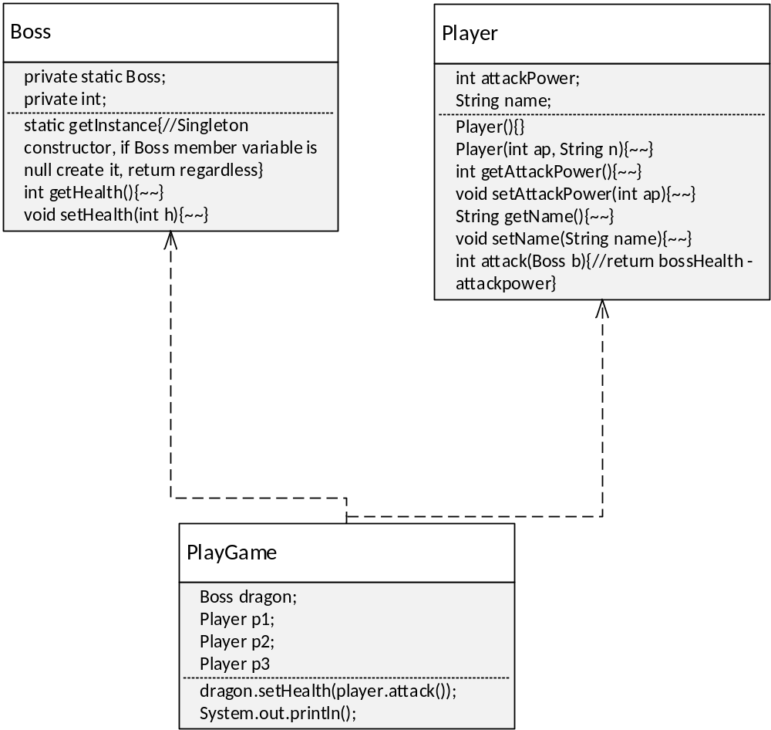

Testing:
What is testing for? Every program you wrote, you are responsible for unit testing it. The first thing to do, once you have a program that “basically works”, is to try to break it. Try to feed your program input(s) in the hope of getting it to misbehave. By “hope” means that the challenge here is to find as many errors as possible, so that you can fix the errors before anybody else finds them. If you go into this exercise with the attitude that “my program works, and I don’t make errors!”, then you won’t find many bugs, and you will feel bad when you do find one or when someone finds one. You’d be playing head games with yourself! The right attitude when testing is, “I’ll break it! I’m smarter than any program--even my own!”
Feed (or try) a few such “problematic” inputs to your program and try to figure out in how many ways you can get it to misbehave. Can you get the program to crash? Testing is a very important part of game development, and can actually be fun. You may input data that is not “sensible”. A program ideally catches all errors, not just the sensible ones--this will make your program resilient against “strange input.”
As a goal, you would like the test to exercise every statement in your program, at least once. Test both positive and negative scenario. One example of positive testing is--if you have an input that requires an integer value, would it work if you give it the numeral 7? Moreover, as an example of negative testing: what happens if you give the previous program a string input of “seven” (instead of the numerical 7)? Identify if your test results are “Passed” or “Failed”. Use the table below, and add at least five test cases of your own!
[Type at least 5 test cases and what was the result? Did the result passed or failed? Do a negative test case too!]
Test # | Test Description | Result  (Passed/Failed)
1 | Created an instance of the Boss Class. | Passed
2 | Created three unique instances of the Player Class | Passed
3 | Call Player.setAttackPower() and pass in a string | Failed, won’t run
4 | Call Player.setAttackPower() and pass in a negative number | Failed, program stuck in loop
5 | Call Boss.SetHealth() and pass in 0; | Players attacked a dead boss, Failed.
 | Add as many rows as needed.

Production Deployment:
[Paste all your own final screens in this section.] Make sure your output screen shot is readable, magnify if necessary so the instructor can easily read it. A sample magnified output is shown below; replace this with your own. 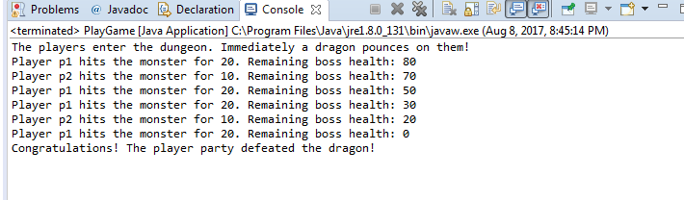
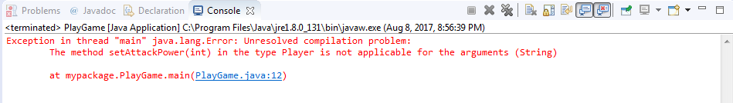
Oops! Haha.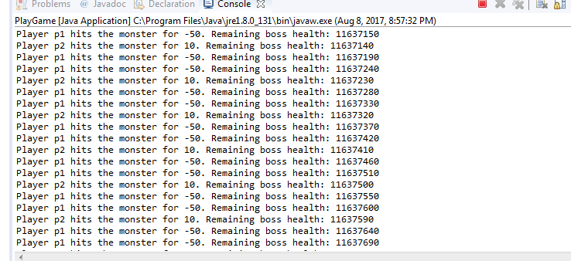
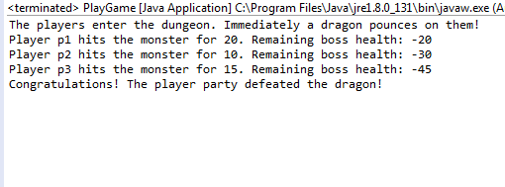

GRADING RUBRIC
Grading Criteria | 3  Exceeds  Excellent  Epic Wow | 2  Meets  Satisfactory  O.K. | 1  Partially Meets  Below Expectations  Not Yet | 0  Does Not Meet  Unacceptable  Fail
Coding | +10-Code is excellent, comments are added, and different techniques were used. | +8-Code is O.K., and program works. | +5-Code works, but still needs improvement. | Unfortunately, no coding.
Output | +5-Outputs are correct, and provided additional output cases. | +3-Output meets requirement and is readable. | +1-There is output, but not readable, and/or needs improvement. | Unfortunately, no output.
Testing | +5-Test cases were excellent, and provided more test cases than what is required. | +3-Provided valid tests, and meets minimum test case requirements. | +1-Test needs improvement, did not make sense, and did not meet minimum test case requirements. | Unfortunately, no testing.
Documentation | +5-Excellent documentation. No misspelling, well formatted, and correct syntax. | +3-Documentation meets requirements. | +1-Documentation has misspelling, or syntax issues, or not clear, or needs improvement. | Unfortunately, no documentation.
Diagram | +5-Excellent diagram. Correct symbols were used and labeled correctly. | +3-Diagram meets requirements. | +1-Diagram does not make sense, or needs improvement. | Unfortunately, no diagram, or diagram was generated.
Late | Excellent, you submitted it before the deadline. | -5, unfortunately for submitting after the deadline. | -10, unfortunately for submitting several weeks after the deadline. | -15, unfortunately, for submitting very late.

